**Running the Collection in Command prompt and Report Generation**

# **Introduction to Newman:**

Newman is the command line collection runner for postman. Through Newman you can run and test a postman collection directly from the command line. Due to which it can be easily integrated with your continuous integration servers and build system.

Also another feature of Newman is that we can generate different reports of the Collection run carried out in the command line. The mostly used form of reports that is generated using postman are HTML, CLI, JSON, Junit etc.

## **Newman Setup:**

Now let us look into how to setup Newman

Newman is built on node.js, so to run Newman make sure you have node.js installed. If you haven’t installed node.js and do not know how to do it don’t worry.

Below I have listed the steps to install node.js and install Newman.

Steps:

1. Install Node.js

Follow the following steps to install node.

* 1. Download Node.js from <https://nodejs.org/en/>
  2. Run the setup/ install node.js. (restart of the device may be required)
  3. Setup the system variable in the environment.
     1. Go to start
     2. Type go to Edit the system environment variable option.
     3. Click on Environment variable button.
     4. Click on the new button of system variable
     5. Set the variable name as nodejs
     6. In the variable value field set the path of the installed node.js folder. Usually, the path is “C:\Program Files\nodejs”.
     7. Click on ok.
  4. Open command and type node –v to check if node is successfully installed.

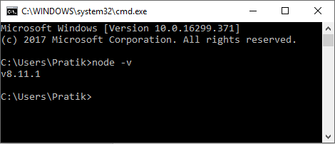

If node is installed the version of the installed node will be displayed as shown in the picture above.

1. Now to install Newman, type “npm install –g newman” in the command line and click Enter button. (It may take couple of minutes for Newman to install)

## **Running Collection in Newman:**

Once Newman is installed, it’s time to run the collection in newman and view its result.

The first thing we have to do before running newman is that the Collection JSON file, Environment JSON file and the Data file all should be inside a single folder.

Keeping this in mind let’s look at the general code used in newman to run a collection

C:\Users\Pratik\Desktop> newman run collection.json -e environment.json -n 2 -r html,cli,json,junit

Description:

1. C:\Users\Pratik\Desktop> : Specifies the directory in why the exported collection, environment and data file is saved in the system. Also the location where the newman reports are saved.
2. Newman run: It is the general code written to start the newman execution which specifies the collection to be run.
3. Collection.json: name of the exported collection file. (Note: Do not name your collection with a space in between e.g.: abc collection.json because the space is not accepted in commend line while running the code.)
4. –e environmebt.json : name of the exported environment file. (Note: Do not name your environment with a space in between e.g.: abc environment.json because the space is not accepted in commend line while running the code.)
5. –n 2 : Specifies the number of times the collection has to be run when used in conjunction with iteration data file.
6. -r html,cli,json,junit : Specifies the type of reports to be generated.

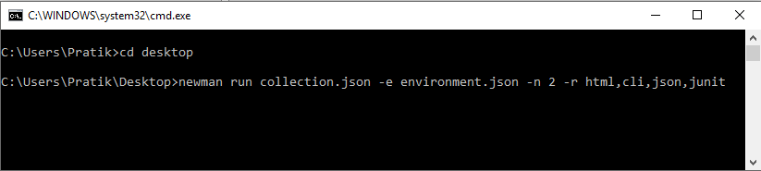

There are many other options provided by newman to customize a run. If you want to look in the other features please visit : <https://github.com/postmanlabs/newman>

## **Viewing Newman Results:**

The –r tag is used in the above newman code example is used to specify different reports to be generated in newman. Once the newman code is run it will generate different results based on the input given. The available reports are: cli, json, html and junit.

Note that spaces should not be used between report names / commas whilst specifying a comma separated list of reporters. For Example:

*-r html,cli,json,junit is correct while -r html, cli , json,junit is wrong way to write.*

Now the cli report will be generated in the Command Prompt itself after you click the enter button.

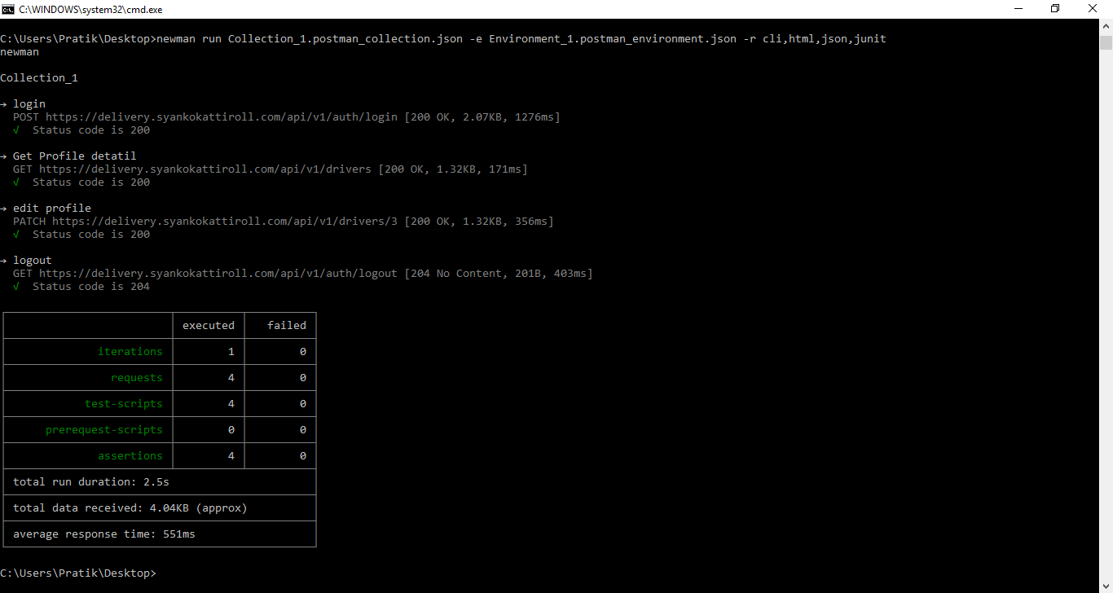

The cli report will look like this.

The html, json, junit report will be saved inside a newman folder in the location where the collection and the environment are kept. In case of above example, the newman folder containing the html, json and junit report will be saved in the desktop.

The HTML report will look like this: